**Team Details:**

| **Sr. No.** | **Name** | **Enrollment No.** |
| --- | --- | --- |
| **Team Member 1** | **Angat Shah** | **202203103510097** |
| **Team Member 2** | **Yash Patel** | **202203103510228** |
| **Team Member 3** | **Gati Shah** | **202203103510261** |
| **Team Member 4** | **Fenil Shilodre** | **202203103510041** |
| **Team Member 5** | **Sarth Chaudhari** | **202303103510106** |

## 

**Objective**

The objective of the **ROI Vision Builder** project is to develop a web-based application that allows businesses, startups and project managers to **visually simulate and calculate Return on Investment (ROI)** for various business scenarios and decisions.

This tool is designed to empower users with a clear, intuitive interface to estimate outcomes, weigh costs against returns and make data-driven strategic choices. It supports interactive modules that guide users through different financial models to assess profitability, payback periods and net returns.

**Code Snippets for Key Functions**

1. **ROI Calculation**

**export const calculateROI = (**

**averageAnnualProfit: number,**

**totalInvestment: number**

**): number => {**

**if (totalInvestment === 0) return 0;**

**return (averageAnnualProfit / totalInvestment) * 100;**

**};**

1. **NPV**

**export const calculateNPV = (**

**cashFlows: number[],**

**initialInvestment: number,**

**discountRate: number**

**): number => {**

**// Convert discount rate to decimal**

**const rate = discountRate / 100;**

**Output**

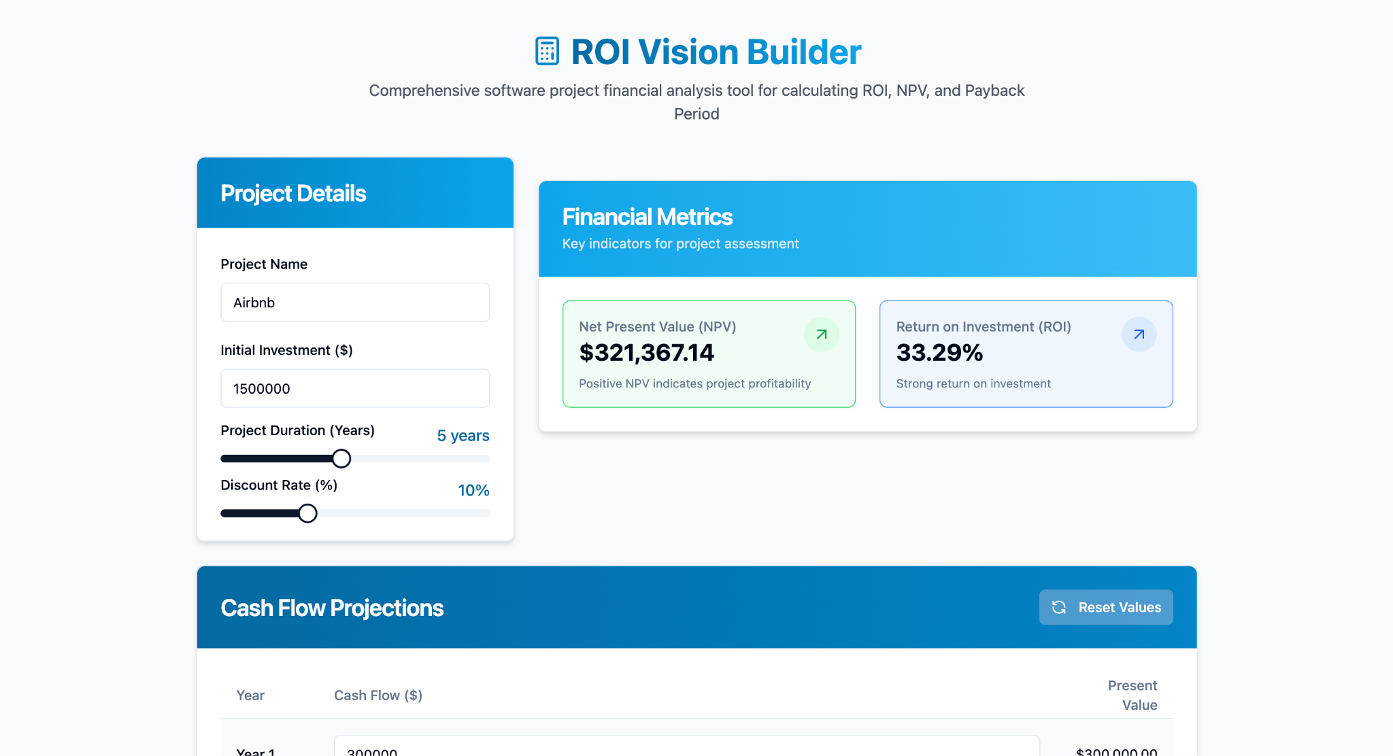

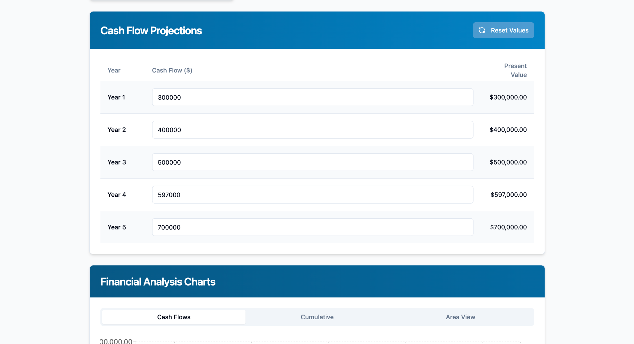

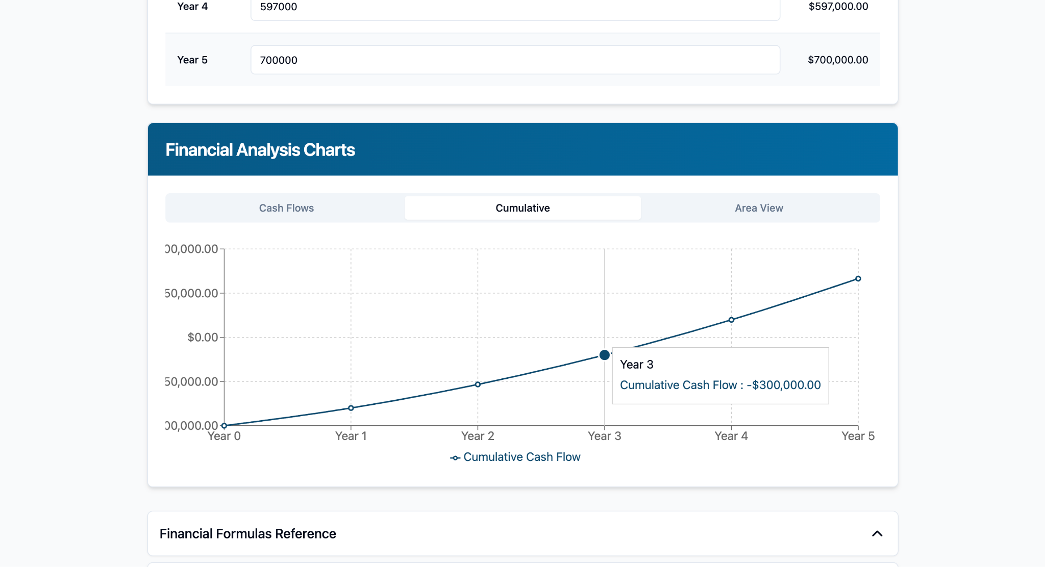

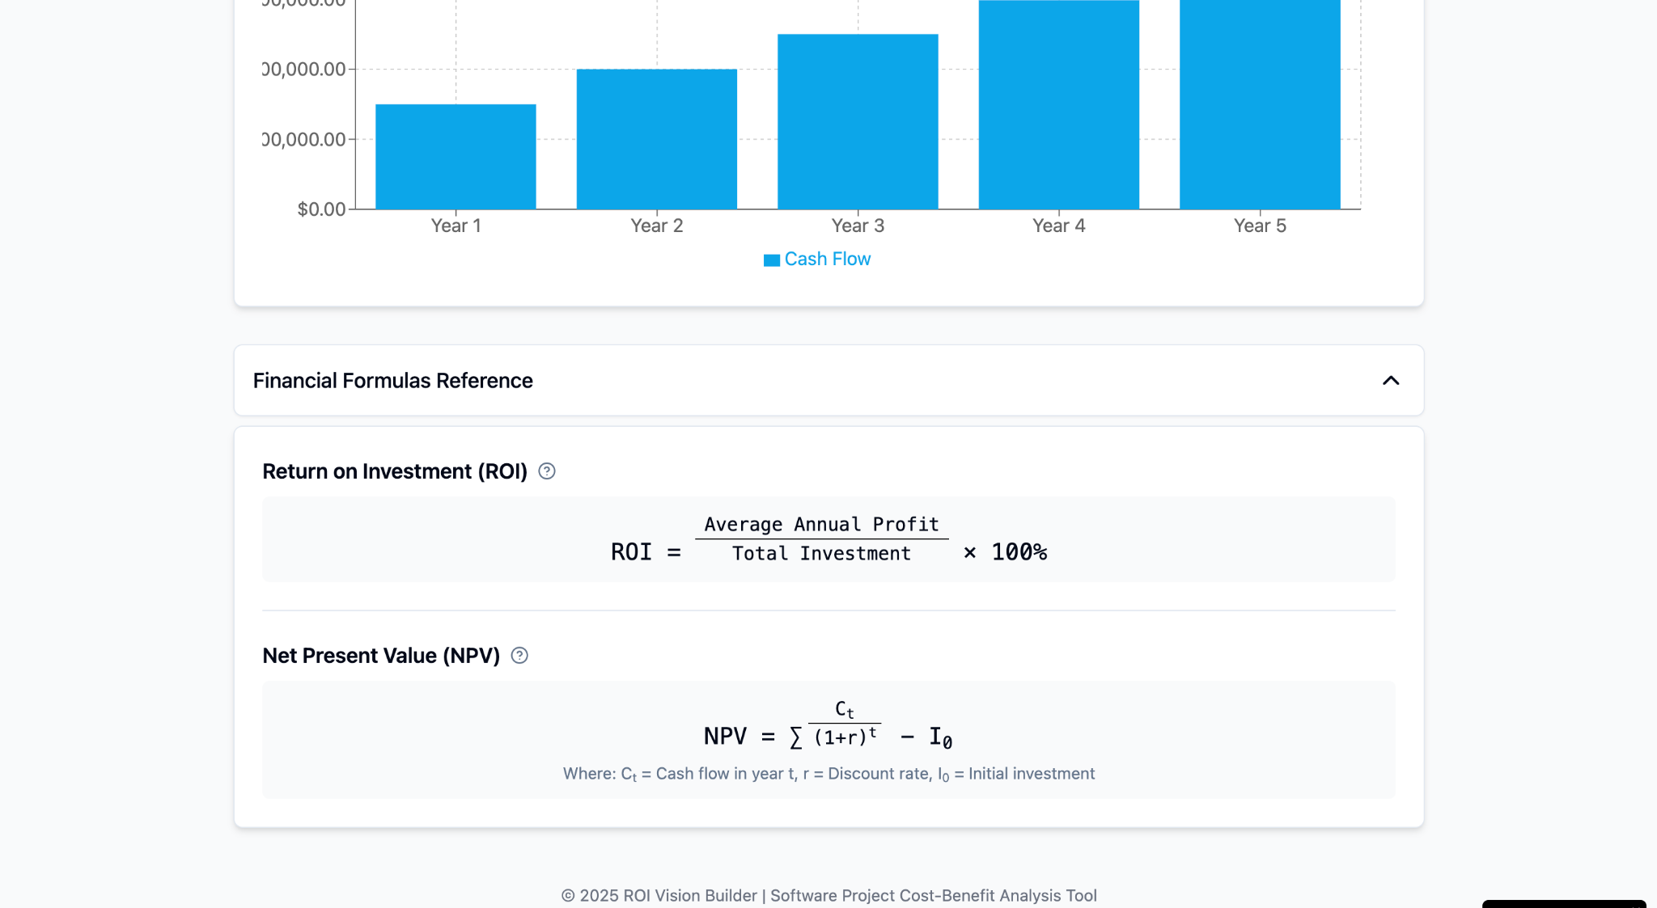

**Tools / Technologies**

* **React.js** – Frontend library for building interactive UI.
* **TypeScript** – Superset of JavaScript providing static typing and improved development experience.
* **JavaScript** – Programming logic.
* **Lovable / Low-code platform** – (Specify exact tool/platform used).
* **Visual Studio Code** – Development Environment.
* **Firebase (optional)** – For user authentication or cloud storage.
* **Git & GitHub** – Version control and collaboration.

## 

## **Future Scope**

* Integrate AI-powered forecasting for ROI prediction based on historical data.
* Add user authentication and cloud-based profile/project storage.
* Export results as PDF or Excel reports for stakeholders.
* Support for industry-specific templates (e.g., marketing ROI, SaaS, manufacturing).
* Include a risk analysis module for comprehensive financial planning.
* Mobile version using React Native.